Diversity and Interculturalism

Discussion Forum Suggestions

There are a number of discussion forums in each course. These are currently empty. As a facilitator, you can add the topics you wish here. We have listed suggested topics for each forum.

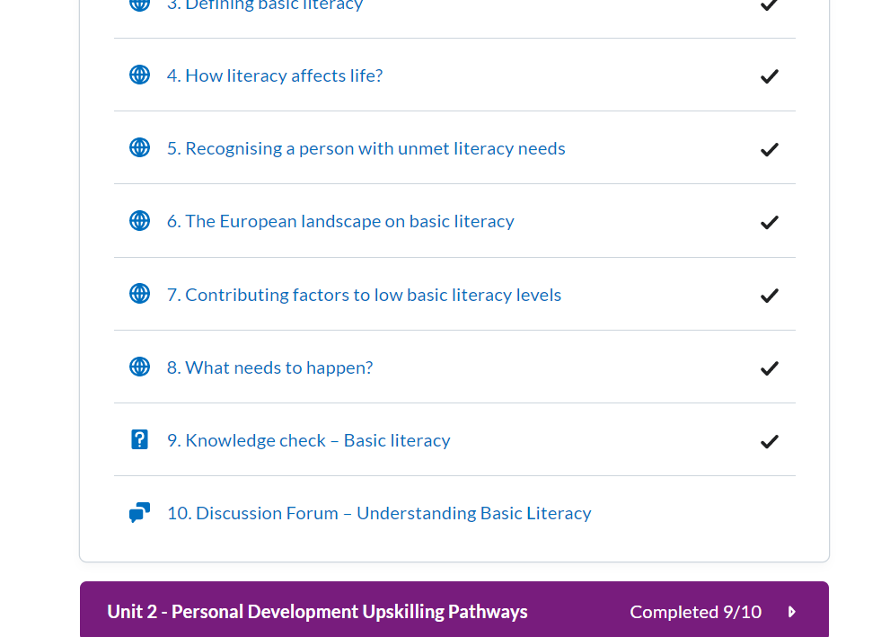

# How to use discussion forums

Click on the Discussion topic and **start a new thread** to edit

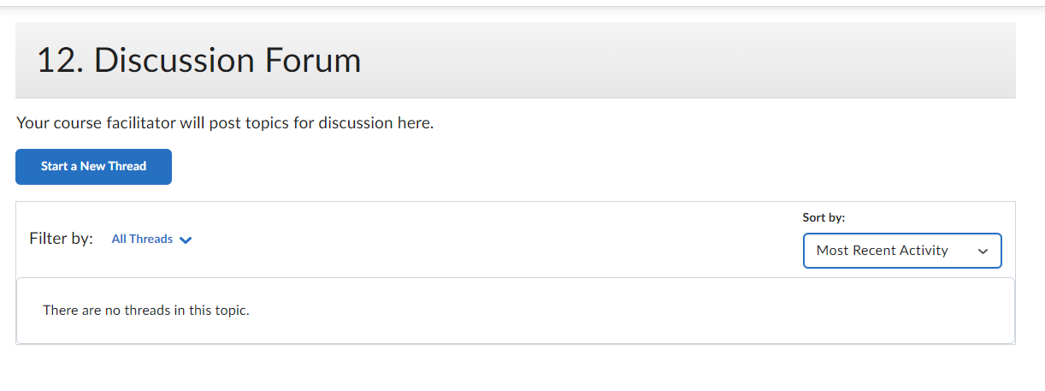

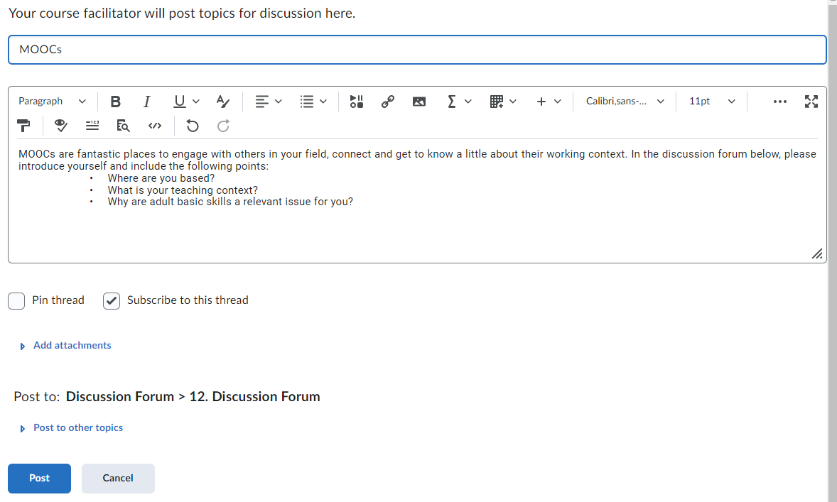

Click **‘post’** to create the topic

# Badges:

Learners will get a Digital badge if they post in each discussion forum. They can either reply to a thread or start their own thread.

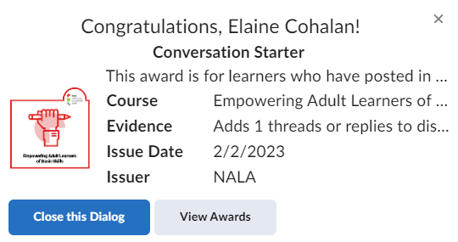

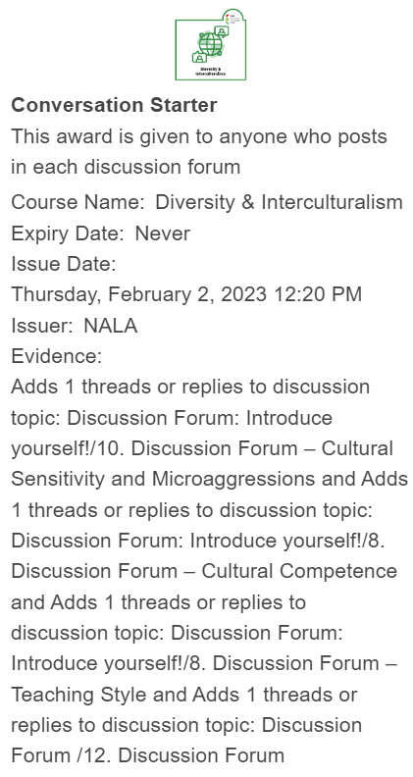

*Unit 1:*

*12.* *Discussion Forum*

Topics suggested for discussion:

1. MOOCs are fantastic places to engage with others in your field, connect and get to know a little about their working context. In the discussion forum below, please introduce yourself and include the following points:

• Where are you based?

• What is your teaching context?

• Why are adult basic skills a relevant issue for you?

2. After going through this unit can you think of ways in which your country, community, education system encourages diversity?

3. Do you think we should aim for equality or equity? What is more important in your experience?

For example: The discussion forum could look like this once it is edited:

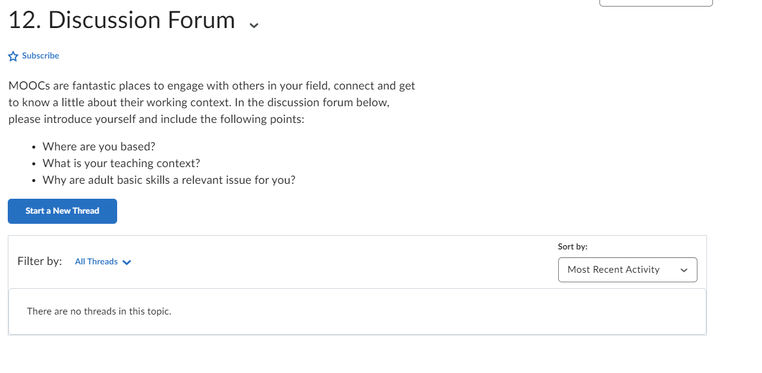

*Unit 2:*

## *10.* *Discussion Forum – Cultural Sensitivity and Microaggressions*

Topics suggested for discussion:

1.Reflect on how you would deal with the following situations in a manner that would avoid microaggressions:

* You have a new foreign learner in the class with a non-Western name which you are unsure how to pronounce.
* One of the learners in the class has a thick foreign accent which you are having trouble understanding.
* There is a single non-white learner in the classroom, who does not participate as much as the rest of the class.
* You’re unsure as to whether a learner is a male or female (or other).
* You see other learners unknowingly use micro-aggressions against other learners (without malicious intent).

2. List down 5 examples of microaggressions that may take place in a/your classroom setting. (10 minutes)

Write about the following:

Describe microaggressions you have experienced or witnessed;

Describe whether these were addressed and the outcome of these situations.

*Unit 3:*

*8.* *Discussion Forum – Cultural Competence*

Topics suggested for discussion:

|  |
| --- |
| **Questions for reflection** |
| Where do I stand on the cultural competence continuum? |
| Was I aware of the perceptions that I had when it comes to multiculturalism or have I discovered something new about myself? |

After watching Mariana Chartier’s talk as an inspiration, think of the following guiding questions and share your thoughts with your peer participants in the forum!

|  |
| --- |
| **Questions for reflection** |
| Think of 2-2 ways that differences can be an advantage and a disadvantage in a classroom setting with adult learners! You may share your personal experience(s) from the past or give imaginary situations too. |
| Try to think of how you might turn disadvantages into advantages for the benefit of your learners! |
| How would you “celebrate” differences within your classroom instead of focusing on the challenges that you might encounter when it comes to teaching adults? Give at least 3 examples. |

*Unit 4:*

*8.* *Discussion Forum – Teaching Style*

Topics suggested for discussion:

What type of teaching style do you possess?

Do you agree with the outcome of the questionnaire you took?

While of course this is not an exact science and many of us will possess a blend of teaching styles it can still be informative to get information on this topic. Do you feel knowing this information is beneficial or do you find it to be limiting? Post the answers to these questions in the discussion forum!

Once you have heard about the 5 different teaching styles in the previously presented podcast (i.e. authority, demonstrator, facilitator, delegator, conductor) and have reflected on their potential advantages and disadvantages, think about the following questions! Collect your ideas first and then share your thoughts with your colleagues in the discussion forum!

|  |
| --- |
| **Questions for reflection** |
| Which style(s) can you identify yourself with the most? Why do you feel most comfortable using that specific style(s)? |
| What could be the most suitable teaching method for adult basic skills training? Can you support your view with experience? Share a positive experience with the group! |
| Which style(s) lead(s) the teacher to greater understanding of their learners in a multicultural setting? Why? |

Think of the materials you have covered so far. Reflect on your own teaching experiences. The questions below may guide you in your reflective process. Make sure to share your thoughts with your colleagues in the discussion forum!

|  |
| --- |
| **Questions for reflection** |
| Have you ever taught basic skills to adults? How was it? What were your major challenges? How did you overcome those? |
| When teaching adults, what techniques do you think prove the most efficient? Do those teaching techniques suit your personality? Why (not)? |
| Can you think of 3 things you would like to improve in your techniques? |